**Bug ID:** 1

**Bug Summary:** Addition operation doesn't work properly

**Environment/URL:** <https://qwallity-dev.onrender.com/calculator>

**Operation System:** Windows 11

**Version**: 1

**Browser:** Google Chrome

**Submit Date:**23.01.2024

**Reporter:** Gohar Galstyan

**Steps to Reproduce:**

1. Open Qwallity application
2. Login
3. Navigation to exercises
4. Open calculator
5. Number 1 input 7
6. Number 2 input 3
7. Select an addition from the Operations list
8. Press the button Calculate

**Expected Result:** 7 plus 3 should get 10.

**Actual Result:** When adding the numbers, we get 2 digits less

**Screenshot/video:** Screenshot is attached

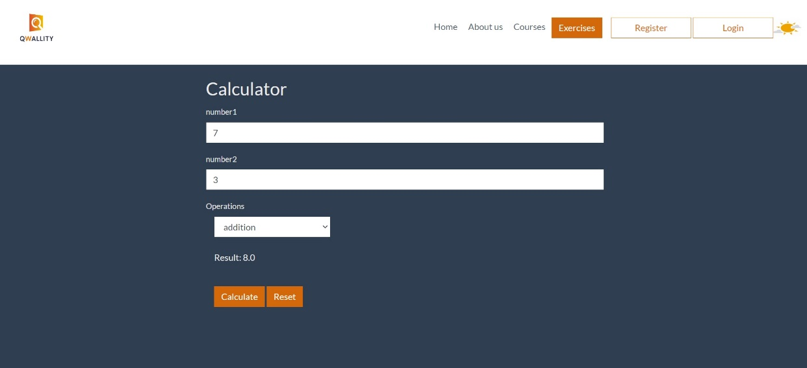

**Notes:** Subtraction, multiplication and division are working correctly

**References: -**

**Severity:** Critical